**Unit 1 Assignment**

Complete the following Unit 1 Assignment exercises. Please read the entire document and the specifications of the assigned work carefully!

Guidelines Completing Assignment Exercises

Extra 2-1 Convert Fahrenheit to Celsius

Extra 3-1 Enhance the Fahrenheit to Celsius application

Extra 3-4 Use a Sales array

# Guidelines Completing Assignment Exercises

* For all the assignment exercises, you will start with the HTML and CSS for the user interface. Then, you supply the JavaScript or jQuery that’s required to get the desired results.
* Unless an exercise specifies that you need to modify the HTML or CSS, you won’t have to do that.
* Make sure every application is coded in strict mode.
* Feel free to copy and paste code from the book applications or exercises that you’ve already done.
* Use your book as a guide to coding.

# Extra 2-1 Convert Fahrenheit to Celsius

In this exercise, you’ll create an application that converts Fahrenheit temperatures to Celsius temperatures by using the prompt() method of the window object and the write() method of the document object. The prompt dialog box should look like this:

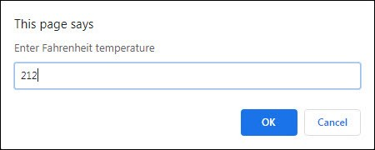

After you write the results, the page should look like this:

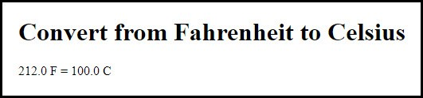

To convert Fahrenheit to Celsius, first subtract 32 from the Fahrenheit temperature. Then, multiply that result by 5/9.

1. Open this file: **exercises_extra\ch02\convert_temps.html**
2. Review the script element at the end of the body section and note that it’s empty. You’ll write the code for this application within this element.
3. Develop this application. Allow the user to enter decimal numbers, and display the Fahrenheit value entered by the user and the calculated Celsius value rounded to 1 digit.

# Extra 3-1 Enhance the Fahrenheit to Celsius application

In this exercise, you’ll add data validation to the application you created in extra exercise 2-1. You’ll also let the user do multiple conversions before ending the application. This is the dialog box for an invalid entry:

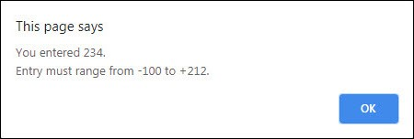

After you enter several temperatures to convert, the page should look like this:

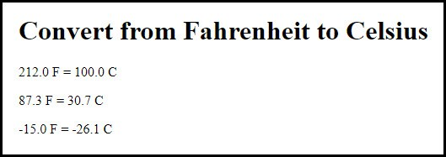

1. If you didn’t already do extra exercise 2-1, do it now. Then, copy the convert_temps.html file into this folder:

**exercises_extra\ch03\**

1. Add data validation to the application so it won’t do the conversion until the user enters a Fahrenheit temperature between -100 and 212. If the entry is invalid, a dialog box like the one above should be displayed.
2. Add a loop to the code so the user can do a series of calculations without restarting the application. To end the application, the user must enter 999 as the temperature.

# 

# Extra 3-4 Use a Sales array

In this exercise, you’ll start with five arrays that represent sales regions, and each array contains four values that represent the quarterly sales for the region. Then, you’ll summarize the data in the page, which should look like this:

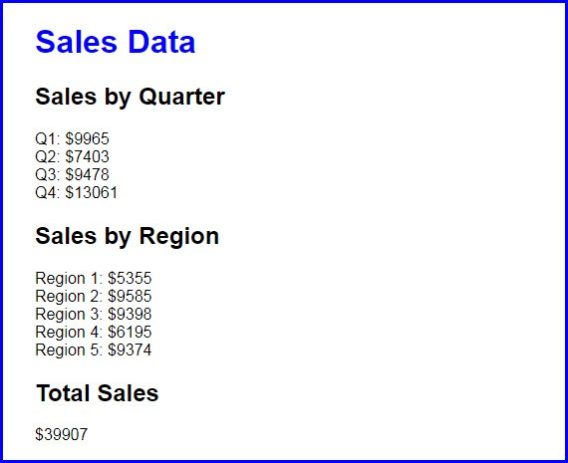

1. Open the application in this folder: **exercises_extra\ch03\sales_array\**
2. In the HTML file, note the link element that refers to the CSS file, and the script element refers to the JavaScript file.
3. In the JavaScript file, note that five arrays are declared with four values in each. Each of these arrays represents one sales region, and each of the values in an array represents one sales quarter. For instance, the sales for the third quarter in region 3 were 2710.
4. Write the code for summing the quarterly sales for each the five regions and displaying them on the page with the document.write() method. To do that, use an <h2> tag for each header and a <br> tag for a line break at the end of each line of sales data.
5. Write the code for getting and displaying the regional sales data.
6. Write the code for getting and displaying the total sales data.